TASK 4:
#include <iostream>
using namespace std;

int main()
{
int n;
int *arr;
int sum = 0;
float avg = 0.0;

cout << "Enter size of an array: ";
cin >> n;

arr = new int[n];

for (int i = 0; i < n; i++)
{
cout << "\nEnter value of element " << i + 1 << ":";
cin >> *(arr + i);

sum = sum + *(arr + i);
}

avg = (float)sum / n;

cout << "Average is : " << avg;

delete[] arr;
}

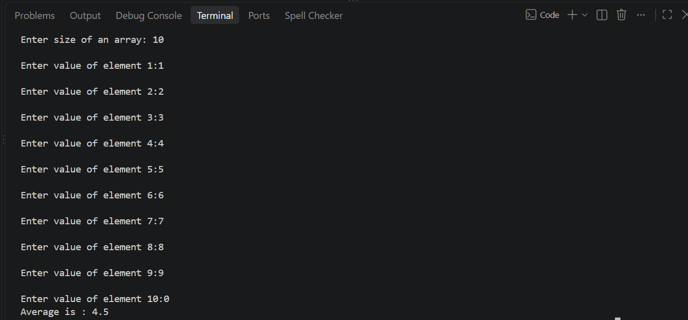

TASK 5:
#include<iostream>
using namespace std;

class Product
{
string product_name;
int *quantity;

public:
Product(string name, int qty)
{
product_name=name;
quantity=new int;
*quantity=qty;
}

Product(const Product& orig)
{
product_name=orig.product_name;
quantity=new int;
*quantity=*(orig.quantity);
}

Product& operator=(const Product& orig)
{
if (this != &orig)
{
delete quantity;

product_name=orig.product_name;

quantity = new int;

*quantity=*(orig.quantity);
}

return *this;
}

void display()
{
cout<<"Product name : "<<product_name<<endl;
cout<<"Quantity : "<<*quantity<<endl;
}

void setQuantity(int qty)
{
*quantity=qty;
}

~Product()
{
delete quantity;
}
};

int main()
{
Product obj1("Laptop", 5);

cout << "Original Object:\n";
obj1.display();

// Copy constructor
Product obj2(obj1);

cout << "\nObject 2 after copying Object 1:\n";
obj2.display();

// Modify copied object
obj2.setQuantity(10);

cout << "\nAfter modifying Object 2:\n";

cout << "Object 1:\n";
obj1.display();

cout << "\nObject 2:\n";
obj2.display();

// Assignment operator
Product obj3("Mobile", 2);

cout << "\nObject 3 before assignment:\n";
obj3.display();

obj3 = obj1;

cout << "\nObject 3 after assigning Object 1 to Object 3:\n";
obj3.display();

return 0;
}

